**MUSIC PLAYER USING PYTHON**

**A**

**PROJECT REPORT**



**Submitted To: Submitted By:**

Ms. Ankita Wadhawan Arpit

Saurav

Kamal

**INTRODUCTION**

The main objective of this project is to design cross-platform media player using python. Python Is Really Very Interesting Language Because this language provides usability to write cross-platform codes that can run on all types of the system without even doing any big changes in codes. This Python module provides a high-level core Music player interface where you are supposed to provide all the remaining high-level logic like the user interface, the playlist logic and the audio data

**HARDWARE REQUIRED**

* Intel Pentium @3.3ghz
* 1 GB RAM
* 120 GB HDD
* LAN or WAN

**SANPSHOT OF MUSIC PLAYER**

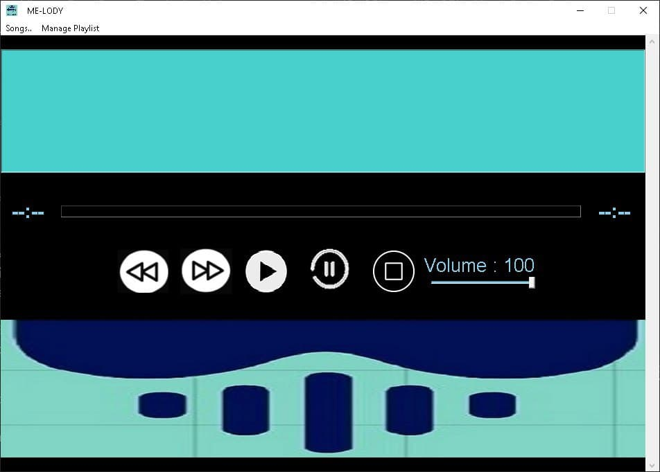

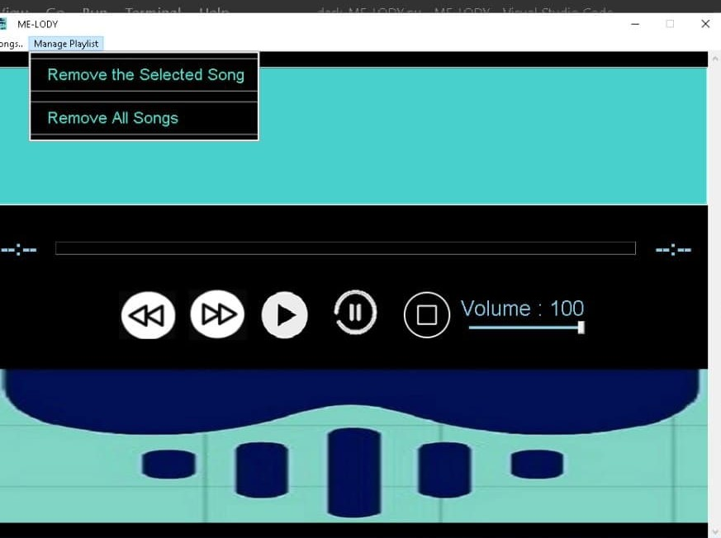

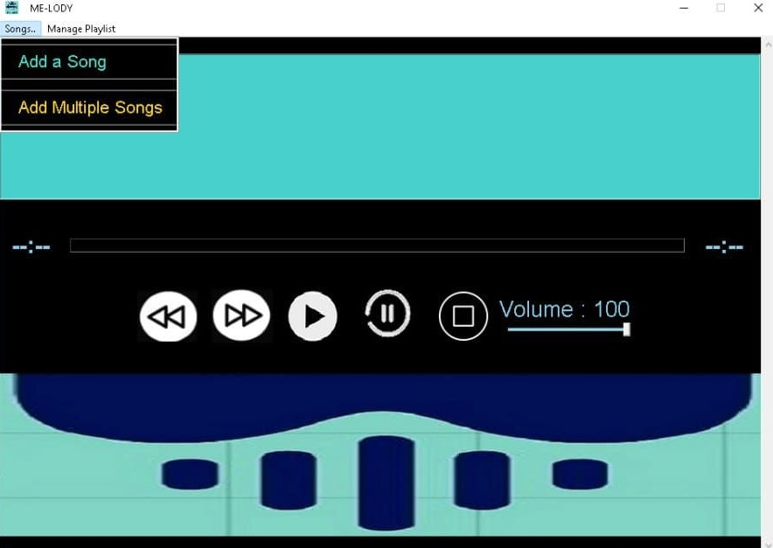

**Advantages/Benefits of Using Python**

The diverse application of the Python language is a result of the combination of features which give this language an edge over others. Some of the benefits of programming in Python include:

1. Presence of ThirdParty Modules:

The Python Package Index (PyPI) contains numerous third-party modules that make Python capable of interacting with most of the other languages and platforms.

2. Extensive Support Libraries:

Python provides a large standard library which includes areas like internet protocols, string operations, web services tools and operating system interfaces. Many high use programming tasks have already been scripted into the standard library which reduces length of code to be written significantly.

3. Open Source and Community Development:

Python language is developed under an OSI-approved open source license, which makes it free to use and distribute, including for commercial purposes. Further, its development is driven by the community which collaborates for its code through hosting conferences and mailing lists, and provides for its numerous modules.

4. Learning Ease and Support Available:

Python offers excellent readability and uncluttered simple-to-learn syntax which helps beginners to utilize this programming language. The code style guidelines, PEP 8, provide a set of rules to facilitate the formatting of code. Additionally, the wide base of users and active developers has resulted in a rich internet resource bank to encourage development and the continued adoption of the language.

5. User-friendly Data Structures:

Python has built-in list and dictionary data structures which can be used to construct fast runtime data structures. Further, Python also provides the option of dynamic high-level data typing which reduces the length of support code that is needed.

6. Productivity and Speed:

Python has clean object-oriented design, provides enhanced process control capabilities, and possesses strong integration and text processing capabilities and its own unit testing framework, all of which contribute to the increase in its speed and productivity. Python is considered a viable option for building complex multi- protocol network applications.

As can be seen from the above-mentioned points, Python offers a number of advantages for software development. As upgrading of the language continues, its loyalist base could grow as well.

**PRODUCT FEATURES**

1. PLAY: We added play option for playing the song which is imported from library of system
2. REWIND: For rewinding the music to play from start.
3. STOP: For stopping the recently played music
4. PAUSE: To pause the recently playing music.
5. REPEAT: Repeat the playing music
6. PLAYLIST: In this we have given option to add songs from system.
7. ADD: By this option we can add songs.